Chapter 6, Solution 1.

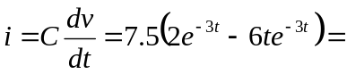15(1 – 3t)e^{-3t} A

p = vi = 15(1–3t)e^{–3t} ⋅ 2t e^{–3t} = 30t(1 – 3t)e^{–6t} W.

15(1 – 3t)e^{-3t} A, 30t(1 – 3t)e^{–6t} W

